Bangladesh University of Business
& Technology

(BUBT)

LAB Report

Course Code : CSE 207
Course Title : Database Systems Lab
Experiment No. : 01

Name: Md. Fahim Islam
ID: 20245103035
Intake: 53
Section: 01
Program: B.Sc. Engg. in CSE

Name: Farha Akhter Munmun
Dept. of Computer Science and Engineering (CSE)
Bangladesh University of Business and Technology

Date of Submission: 13/08/2025
Signature of Teacher
Md. Fahim Islam
1. Create a DB named “BUBT_DB1”.
Md. Fahim Islam

CREATE DATABASE `fahim_035`;
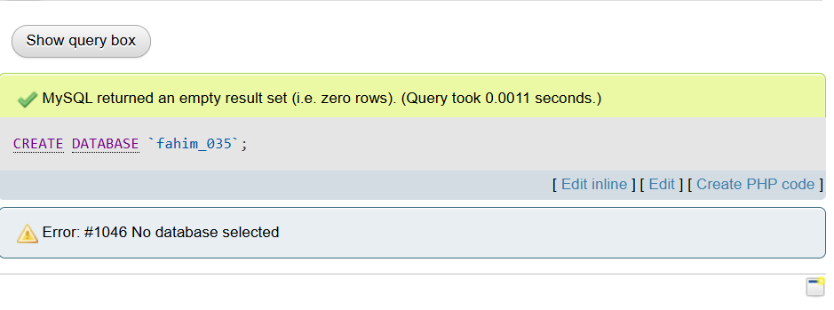
Md. Fahim Islam
Md. Fahim Islam
2. Create three tables in this DB named “Student”, “Faculty”,
“Course”.

CREATE TABLE `Student`(`Name` varchar(20), `St_Id` int(3), `NID` int(4), `Intake` int(3), `Section` int(2), `CGPA` float(3,2));
CREATE TABLE `Faculty`(`Name` varchar(20), `Short code` varchar(4), `Course Code` varchar(8), `Conduct Semester` varchar(10));
CREATE TABLE `Course`(`Course Title` varchar(20), `Course Code` varchar(8));
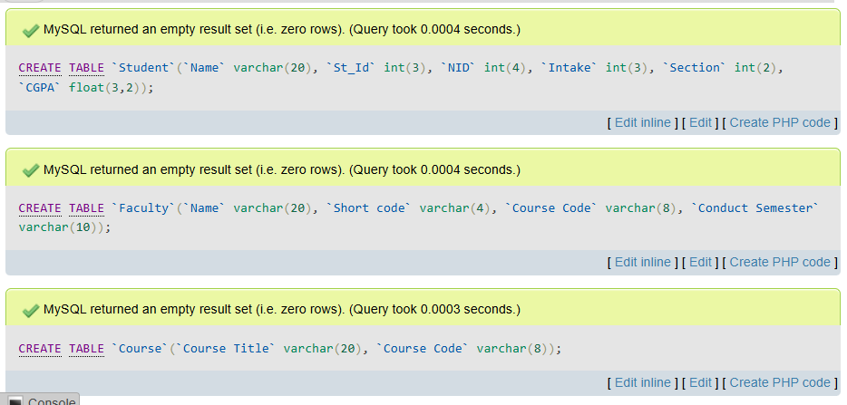

3(a). Update the short code whose short code is NULL.
Md. Fahim Islam

UPDATE `faculty` SET `Short code`='NAR' WHERE `Name`='Nadia Afrin Ritu';
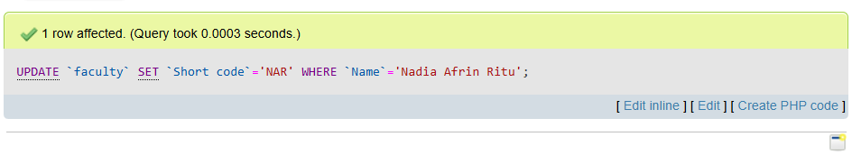
3(b).Update the course code that is NULL.

UPDATE `faculty` SET `Conduct Semester`='CSE 207' WHERE `Short code`='SKN';
UPDATE `course` SET `Course Code`='CSE 209' WHERE `Course Title`='System Analysis Design';
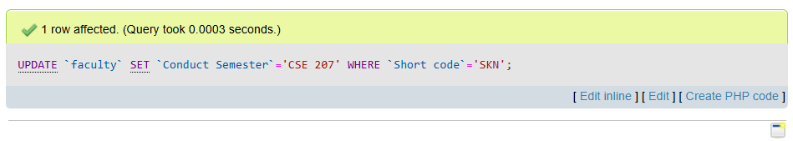
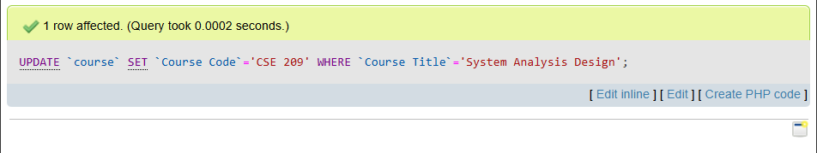
3(c). Update the conduct semester that is NULL.
Md. Fahim Islam

UPDATE `faculty` SET `Conduct Semester`='Summer 2020' WHERE `Short code`='NAR';

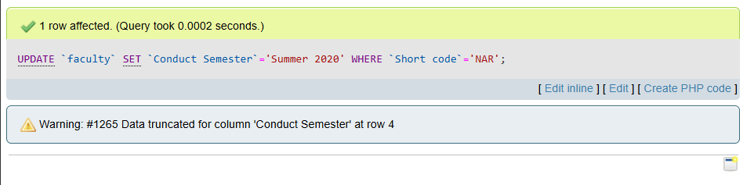
3(d). UAdd a new column named “Age” in student relation.

ALTER TABLE student ADD COLUMN `Age` int(2);
Md. Fahim Islam
3(e). Update the age of each student.

UPDATE `student` SET `Age`='21' WHERE `St_Id`='1';
UPDATE `student` SET `Age`='20' WHERE `St_Id`='2';
UPDATE `student` SET `Age`='26' WHERE `St_Id`='33';
UPDATE `student` SET `Age`='25' WHERE `St_Id`='6';
UPDATE `student` SET `Age`='19' WHERE `St_Id`='23';
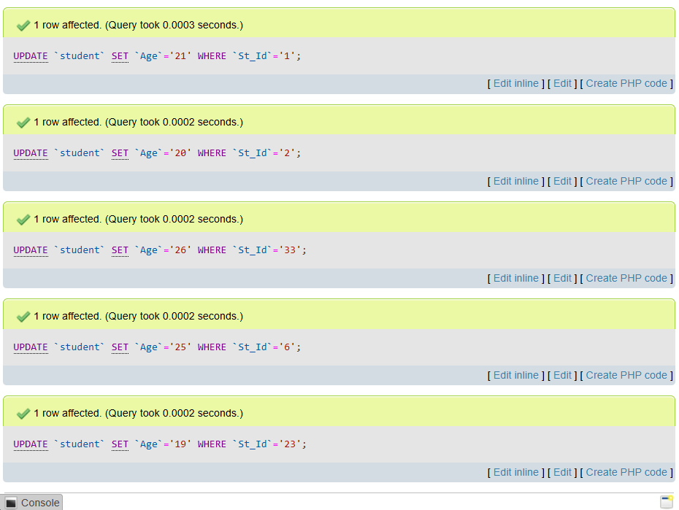
3(f). Find the names of all Courses in the Course relation.

SELECT `Course Title`FROM `course`;
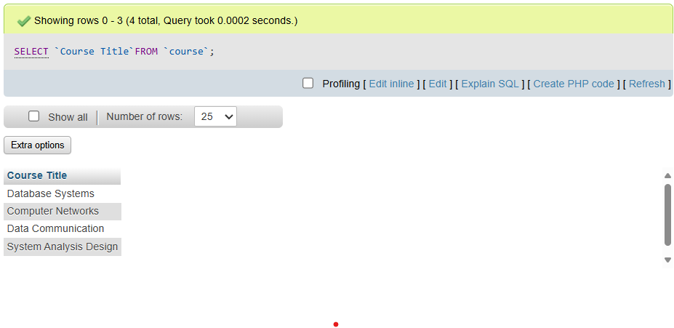
Md. Fahim Islam
3(g). Find the names of all teachers who has conducted in
summer 2019.

SELECT `Name` FROM `faculty` WHERE `Conduct Semester`='Summer 2019';
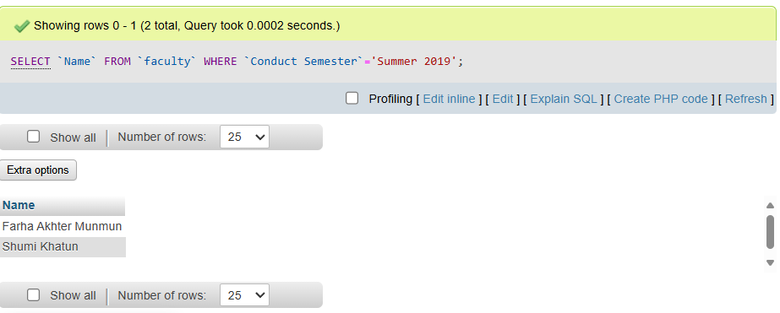
3(h). Find the names of all students whose CGPA is greater than 3.50.

SELECT `Name` FROM `student` WHERE `CGPA`> 3.5;
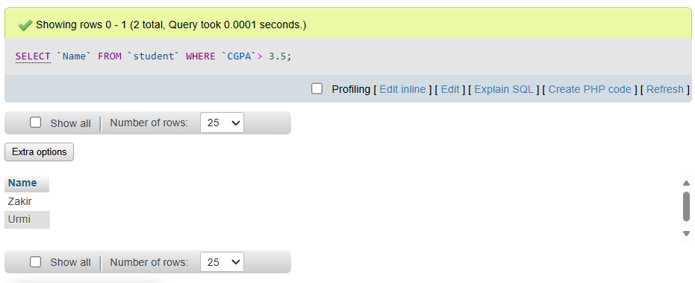
Md. Fahim Islam
3(i). Add a new column “Offered semester” after the column “Course Title”.
Md. Fahim Islam

ALTER TABLE course ADD COLUMN Offered_Semester varchar (20) AFTER Course_title;
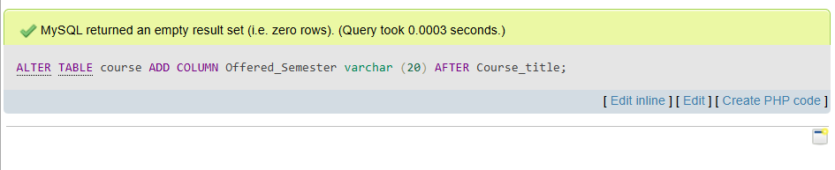
3(j). Find the name and CGPA of each student by their CGPA (Ascending order.).

SELECT Name,CGPA FROM student ORDER BY CGPA ASC;
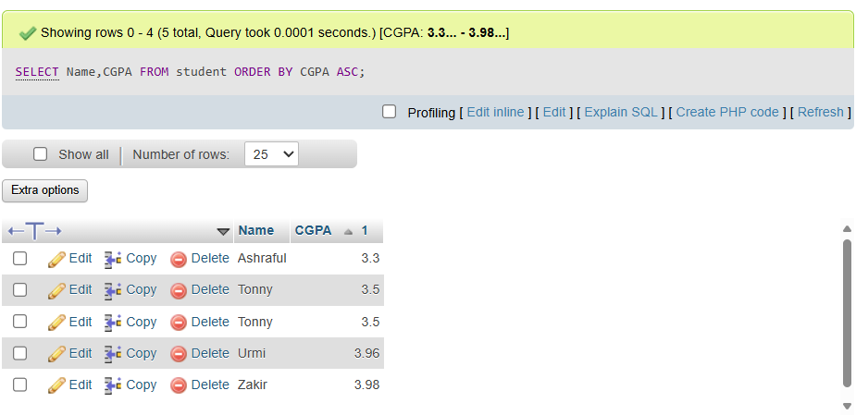

3(k). Find the name of all students whose age is greater than 22 and CGPA is greater than 3.50.
Md. Fahim Islam

SELECT Name FROM student WHERE Age > 22 AND CGPA > 3.50;
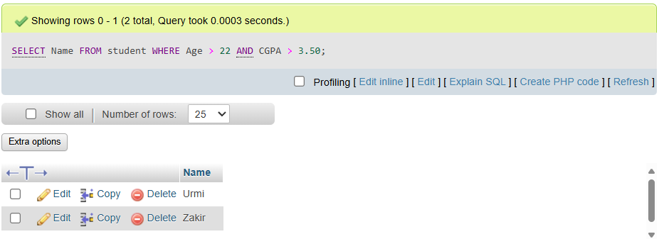
3(l). Find the Id of all those students who are from 44 intake or CGPA is less than 3.40.

SELECT Name FROM student WHERE Intake = 44 OR CGPA <3.40;
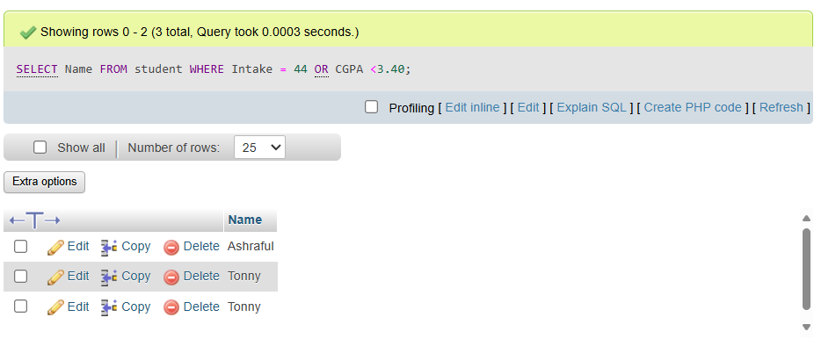
3(m). Find the Id of all those students whose CGPA is 3.30 or 3.50 or 3.96.

SELECT St_Id FROM Student WHERE CGPA IN (3.30, 3.50, 3.96);
